Blooming Thermometers

Created by the Center for Science Education

<https://scied.ucar.edu/activity/blooming-thermometers>

Grade Level: Middle School

Time: One class period (45 minutes)

In this lesson, students learn about the Japanese Festival celebrating the appearance of cherry blossoms in the spring and analyze average bloom-date data from over 1000 years of records to understand how the climate has changed.

**Learning Goals**

* Students will learn that plants and other living things respond to seasonal changes.
* Students learn that the timing of seasonal changes and reactions of these natural phenomena will change as climate changes over long periods of time.

**Learning Objectives**

* Students will graph and analyze cherry bloom data from Japan that shows evidence of cooling from the 16th to 19th centuries, which roughly correlates with the Little Ice Age.
* Students will evaluate a claim that recent cherry blossom data shows evidence of climate warming by exploring additional bloom data and articulating their reasoning.

**Materials**

* [Blooming Thermometers slides](https://docs.google.com/presentation/d/1pqPoFtIIikUhhVJCBw9GZhJTve9SnD-i6HfGayXKN8I/edit#slide=id.gc6586c2504_0_66) (download)
* Classroom computer/projector to share slides
* For each student:
  + [Blooming Thermometers Student Page](https://scied.ucar.edu/sites/default/files/documents/Blooming_Thermometers_Student_Page.pdf) (download)
  + Pencil
  + Ruler

**Preparation**

* Make one copy per student of the Blooming Thermometers student page.
* Familiarize yourself with the slides and the data that students will analyze.

**Directions**

**Introduction: How seasonal changes relate to climate**

1. Ask students to brainstorm how they know that seasons are changing. What changes? Is it just the temperature? How do living things react to the change in temperature? (Examples: Leaves turning color, crops are harvested, flowers bloom, birds migrate, people turn air conditioners on, etc.)
2. Help students make a connection between the seasonal changes that they brainstormed and climate by asking: *Do the seasonal changes that the class brainstormed happen at exactly the same time each year? What might cause the timing to be different?*
3. Help students make the connection to climate change by asking: *If the climate cooled, how would these phenomena be affected? If the climate warmed, how would these phenomena be affected?*
4. Explain that in this lesson, the class will investigate data about one phenomenon that is affected by changing seasons: the blooming of cherry blossoms.
5. Introduce students to the cherry tree blossoms of Japan using the slide show.
   * Explain that each spring the Japanese celebrate the appearance of cherry blossoms (sakura) with the festival of Hanami. (Slides 3-4 give an example of the festival in Kyoto, which is where the bloom data set is from.)
   * Tell students that cherry blossoms have an importance in Japanese culture and people have been observing them for centuries. There are records about the timing of cherry blossoms from over the past 1000 years. (Slides 5-7 show historical images of cherry trees in bloom in Japan.)
6. Ask students the question on Slide 8: *What can blooming cherry trees tell us about climate?* Confirm that cherry trees bloom when it warms in the spring (Slides 9-10). Explain that scientists have used these records to understand temperature change. In this lesson, the class will do the same.

**Part 1: Analyzing cherry blossom data as evidence of past and present climate**

1. Distribute the Blooming Thermometers Student Page and explain the concept of mean blooming date. The data from each century are averaged. Because the data is averaged, small variations in bloom time are not present. Additionally, one year’s blooming date is also an average because not all trees bloom at exactly the same time.
2. Have each student create a graph of blooming date versus time. Students are instructed to make a bar graph. If students are not familiar with bar graphs, show examples from outside this lesson. Point out that the graph on the student page has a y-axis with the largest number on the bottom and the smallest at the top.
3. Students should add the mean (April 15) to the graph by drawing a flat line across and answer the questions about which time periods have a bloom date that is later than the mean and which have a bloom date that is earlier than the mean.
4. Once students have created graphs, ask them to note which centuries had the coolest climate and which centuries had the warmest climate.
5. Review student responses to the questions on the Student Page.
6. Show students the graph on slide 12, which shows temperature data over 1700 years. Ask students if what they found in the bloom data is similar to this graph. Students should notice that the timing of the Little Ice Age is the same as the centuries when bloom date is later in April. (For more information about the Little Ice Age, see background section below.)

**Part 2: Assess a claim about the most recent bloom dates**

1. Have students look specifically at the most recent century of data show the earliest bloom date (April 11). Ask students to assess the claim: *The most recent data shows an earlier bloom date because our climate is warming* (slide 13). (If students have not already learned about human-caused climate warming, you may want to provide some context for this claim.)
2. Note that the data students graphed ends in 2005. Have students brainstorm what other evidence they would like to have to evaluate the claim. (It's likely that students would like to have the bloom dates for recent years and temperature data, so these are included on slides 14 and 15.)
3. Show students the bloom data (Slide 14) and global average temperature data (Slide 14). Students may notice that the bloom data for recent years looks more variable. Remind students that data averaged over centuries will appear less variable than the data for each year.
4. You may also wish to have students search for other evidence that they brainstormed and look up more recent bloom data. The city of Kyoto issues a cherry blossom forecast each spring which can be accessed online.
5. As an exit ticket, have each student write their reasoning citing the evidence. *(Students should note that the warmer climate is the likely reason that cherry trees are blooming in Kyoto earlier in the spring. Students may also include information from the introduction about how buds open when temperatures are warm enough.)*

**Background**

Phenology is the study of biological events that change in response to their environment. For example, birds and butterflies migrate, frogs spawn, and many animals hibernate with the seasons. Likewise, the appearance of flowers, such as cherry blossoms, is a response to the local weather and climate. On an annual basis, many biological events respond to weather, whereas over long periods of time the phenomena shift gradually, earlier or later in the year, in response to climate.

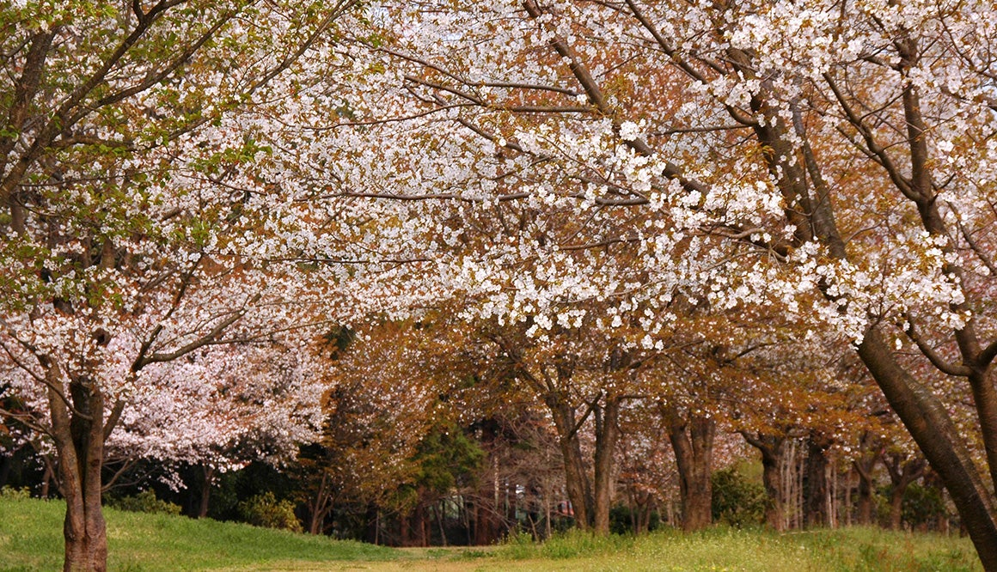

Wild cherry trees in bloom in Japan  
Credit: Autan/Flickr

For hundreds of years, the Japanese have held a celebration each spring called Hanami in honor of the ap­pearance of cherry blossoms (sakura). Originally a social event reserved for the nobility, it has evolved into one that most Japanese share. Ancient documents record the date of past festivals and scientists have been able to use this information to calculate the mean annual blossom date for cherry trees over the past 1100 years. The change in the bloom dates provides insight into past changes in climate.

The early appearance of blossoms indicates a mild winter and warmer climate whereas a late blossom date indi­cates longer, harsher winters and a cooler climate. The table on the student page indicates the mean blooming date each century for the years 900 to 2005 for cherry trees in the city of Kyoto, Japan. (The data is from Aono and Kazui, 2008 – see full citation below)

In this activity, the bloom data that students analyze shows a cooler period between the 16th and 19th centuries – roughly the timeframe known as a Little Ice Age. This was not a true ice age, but, instead, a period of slightly cooler temperatures. The data indicates a much earlier bloom date for the most recent timeframe, 1900-2005, which is due to human-caused climate warming. In part 1 of this activity, students graph all the data and observe that some times were likely cooler and others were warmer. In Part 2 of the activity, students are asked to evaluate a claim that the most recent data is indicating the current, warmer climate. They list evidence that they would like to have to evaluate the claim and look at the timing of the most recent cherry bloom data from Kyoto and also examine a graph of global temperature change, which all supports the claim that global climate change has caused the earlier bloom date in the most recent timeframe.

* Long-term data on the student page are published in: Aono, Y., and Kazui, K., 2008, Phenological data series of cherry tree flowering in Kyoto, Japan, and its application to reconstruction of springtime temperatures since the 9th century, International Journal of Climatology, 28: 905-914.
* Recent data in the lesson slides are from the archived page [JNTO Global Cherry Blossoms Kyoto](https://web.archive.org/web/20210410232540/https:/www.jnto.go.jp/sakura/eng/city.php?CI=29)

*This activity is included in the*[*CLEAN Climate and Energy Resource Collection*](https://cleanet.org/clean/educational_resources/collection/index.html) (https://cleanet.org/clean/educational_resources/index.html)*, a peer-reviewed collection of activities, curriculum, videos, and other tools for teaching.*